  
ESCUELA SUPERIOR   
PÓLITECNICA DEL LITORAL  
  
**ALAMEDA DEL RÍO**   
  
**AUTHORS:**

* AGUILAR MORA OSWALDO
* BERMUDEZ MOREIRA KAREN
* BERNAL MOREIRA GUILLERMO
* ORTIZ HOLGUIN EDUARDO
* WONG PAVON HUGO

**SUBJECT:** SOFTWARE ENG. II  
**TUTOR:** PHD. MERA CARLOS  
**DEADLINE:** 2020/07/12

**Content**

1. Abstract 2

2. Description 2

2.1. Client 3

2.2. Team 3

2.3. Tutor 3

2.4. Product 3

3. Product Specifications 5

3.1. Web 5

3.2. Resident Mobile app 5

3.3. Security Staff Mobile app 5

3.4. Component Diagram 5

3.5. Deployment Diagram 6

4. Scrum Methodology 7

4.1. Roles 7

4.2. Sprints 7

4.3. Team Speed 8

4.4. User Stories 8

4.5. Scrum Poker 9

4.6. Backlog 10

4.7. Dependencies 15

5. Project Control 16

5.1. Click Up 16

5.2. GitHub 19

5.3. Teams 20

5.4. Meetings Rules 20

6. Technology, Tools and implementation decisions 22

6.1. Overview 22

6.2. React Native and React.js 22

6.3. React Hook 24

6.4. GraphQL 24

6.5. Django 25

6.6. Django Graphene 25

6.7. Grommet 26

6.8. EsLint 26

6.9. Airbnb Style Guide 27

6.10. Jest 28

6.11. Chrome DevTools 28

6.12. Android Profiler 29

6.13. Django Roles and GraphQL-JWT 29

6.14. Windows Server 2003 30

6.15. PostgreSQL 30

7. Pre-Sprint 31

7.1. Meetings 31

7.2. Considerations 31

8. Sprint 1 32

8.1. Week 1 32

8.2. Week 2 32

8.3. Week 3 32

8.4. Meetings 32

8.5. Client Accpetance 33

1. Abstract

This document contains the report corresponding to the project **“ALAMEDA DEL RÍO”** of **GROUP#4** belonging to the **SOFTWARE ENGINEERING II** course of **2020-PAO I**.

The report contains a description of the project, client information, scrum methodology, implementations, and important decisions.

1. Description

The project is a continuation[1] of the project of **SOFTWARE ENGINEERING I** course of **2019-PAO II**.

* 1. Client

The client of the project is **“Alameda del Río”**, Alameda is urbanization in Guayaquil near to Daule river and Terminal Terrestre Highway.

The represent of **Alameda** in the project is Eng. Pedro Xavier Gavilanez Chiriboga, president of “Alameda del Río”.

* 1. Team

The team initially consisted of four members that carried out the requirements gathering and the tasks of **SOFTWARE ENGINEERING I** course of **2019-PAO II**. The initial four members are:

In **SOFTWARE ENGINEERING** **II** course of **2020-PAO I** the team received new incorporation completing five members[2]. The new member is:

* Aguilar Mora Oswaldo Josmany
  1. Tutor

The tutor of the project in **SOFTWARE ENGINEERING I** course of **2019-PAO II** was Dr. Carlos Mera, in the second part of the project in **SOFTWARE ENGINEERING II** course of **2020-PAO I** the tutor continues another term with the team.

* 1. Product

The initial scope of the project in **SOFTWARE ENGINEERING II** course of **2019-PAO II** consisted in a Web Administrator, database, Mobile apps for residents and security staff, hardware implementation in urbanization but since the COVID[3] emergency in Ecuador and the mobility restriction affect the final scope consists only in:

* Web Administrator.
* Resident Mobile App.
* Security Staff Mobile App.
* Database.

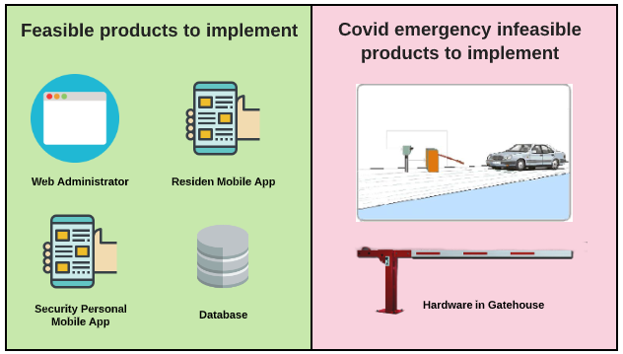

**Figure 1.- Redefinition of project scope for COVID emergency.**

1. Product Specifications
   1. Web

The client requires a Web module for the Administrator, in this module the administrator will create de profiles of residents and security staff, the management of these users, and the possibility of generating aliquots and reports.

* 1. Resident Mobile app

The client requires a mobile app for the resident, in this app, the resident will control the staff information, will generate invitations for his friends, and receive the information and deadlines of the aliquots. Additionally, the resident will receive a notification when a visitor shows up at the gatehouse of the urbanization.

* 1. Security Staff Mobile app

The client requires a mobile app for the security staff, in this app the security staff will see the actives invitations and send to the resident the notification of the visitor in the gatehouse. Additionally, the security staff will see the information on payments and aliquots of the residents in order to authorize or deny certain services to the residents.

* 1. Component Diagram

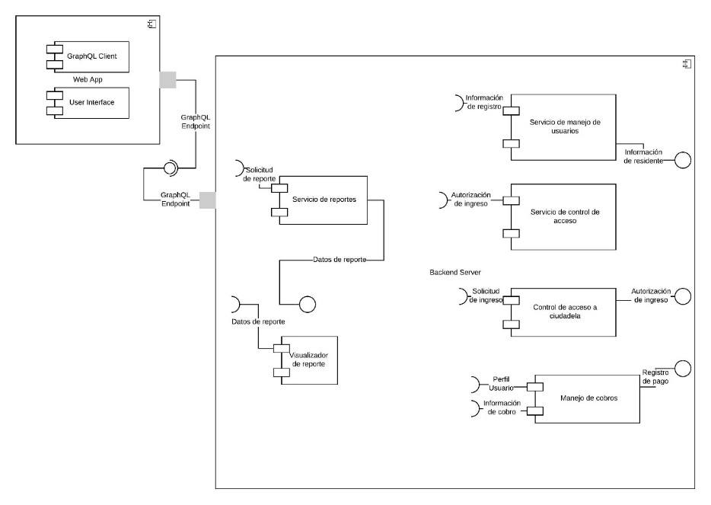

**Figure 2.- Alameda Project - Component Diagram**

* 1. Deployment Diagram

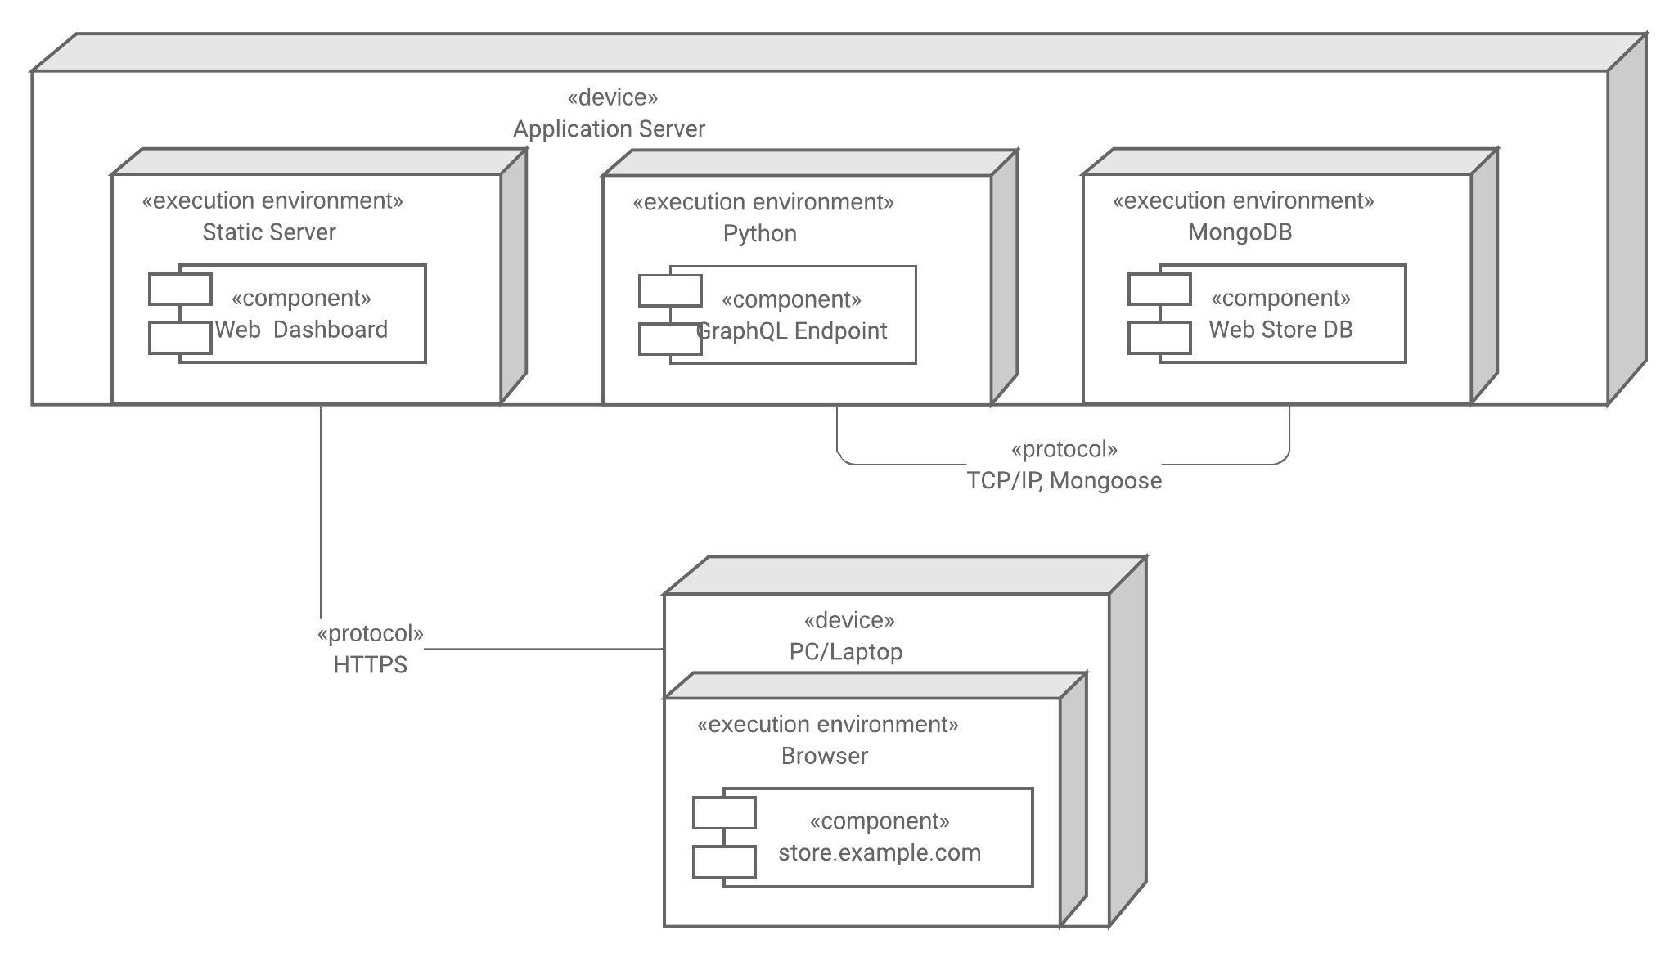

**Figure 3.- Alameda Project - Deployment Diagram**

1. Scrum Methodology
   1. Roles

|  |  |  |
| --- | --- | --- |
| **MEMBER** | **ROLE** | **START SEMESTER** |
| **Guillermo Enrique Bernal Moreira** | **Scrum Master** | **2019 - PAO II** |
| Hugo Bryan Wong Pavon | Developer Team | 2019 - PAO II |
| **Karen Monserrat Bermudez Moreira** | **Product Owner** | **2019 - PAO II** |
| Luis Eduardo Ortiz Holguin | Developer Team | 2019 - PAO II |
| Oswaldo Josmany Aguilar Mora | Developer Team | 2020 - PAO I |
| **Eng. Pedro Xavier Gavilanez Chiriboga** | **Client** | **2019 - PAO II** |

**Table 1. Scrum Roles**

* 1. Sprints

The scrum project consists of three sprints of three week[4], the last sprint ends a week before the second partial evaluation.

|  |  |  |  |
| --- | --- | --- | --- |
| **Sprint 1** | Week 1 | 29-jun | 4-jul |
| Week 2 | 6-jul | 11-jul |
| Week 3 | 13-jul | 18-jul |
|  |  |  |  |
| **Sprint 2** | Week 1 | 20-jul | 25-jul |
| Week 2 | 27-jul | 1-aug |
| Week 3 | 3-aug | 8-aug |
|  |  |  |  |
| **Sprint 3** | Week 1 | 10-aug | 15-aug |
| Week 2 | 17-aug | 22-aug |
| Week 3 | 24-aug | 29-aug |
|  |  |  |  |
|  | **Deadline** | **31-aug** | **4-sep** |

**Table 2.- Sprints divisions and dates**

* 1. Team Speed

Considering the rule of 1 effort point is equivalent to 1 hour/men the team speed for a sprint is 117 points.

|  |  |  |  |  |
| --- | --- | --- | --- | --- |
| **SOFTWARE ENGINEERING II - SCRUM ALAMEDA** | | | | |
| **MEMBER** | | **ROLE** | **H/M WEEK** | **SPEED SPRINT** |
| Eduardo Ortiz | | D.T. | 7,5 | 22,5 |
| **Guillermo Bernal** | | **S.M.** | 8 | 24 |
| Hugo Wong | | D.T. | 8 | 24 |
| Karen Bermudez | | D.T. | 7,5 | 22,5 |
| Oswaldo Aguilar | | D.T. | 8 | 24 |
|  |  |  | **39** | **117** |

**Table 3. Team Speed calculation**

* 1. User Stories

The project consists of 69 user stories divided into the three roles and an initial story; the codification of the stories follows the structure(**USER-ACTIVITY-COUNTER**).

The available users’ codes are:

* AL referring to Urbanization “Alameda del Río”.
* AD referring to Web Administrator or Alameda Administrator.
* PS referring to Security Staff.
* RE referring to Alameda resident.

The available activity codes are:

* MC referring to the profile’s management.
* FU referring to systems functionalities.
* This code isn’t present in the initial story AL-00.

The counter number follow three rules and one exception:

* Is a number of two digits.
* The counter starts in 01 and it’s incremental in the next story.
* In the case of the counter in range 1-9, the number was preceded by a 0 in order to complete two digits.
* The exception is in the initial project story AL-00 that refers to the environment creation.

The stories priorities are:

* Urgent.
* High.
* Normal.
* Low.
  1. Scrum Poker

In order to estimate the user stories, the team scheduled a meeting on Friday 26 of June, the rules and considerations are:

* <https://play.planningpoker.com/play/game/GaKn7U6ZdVrDnyYpsGK4rMy19FNtxgcv>.
* The meeting platform is Teams, urgent, and obligatory.
* The host and environment manager are Oswaldo Aguilar Mora.
* The equivalence of an effort point is 1 hour/men.
* Three votes with the same estimation are considered a group agreement.
* In case of disagreement, the team should talk and later vote again.
* Modification of votes is allowed.
* The scale is [0, 1/2, 1, 2, 3, 5, 8, 13, 20, 40, 100, ?, Pass] and No break.
* In case of all members vote ? or Pass, the tutor vote will be considered.

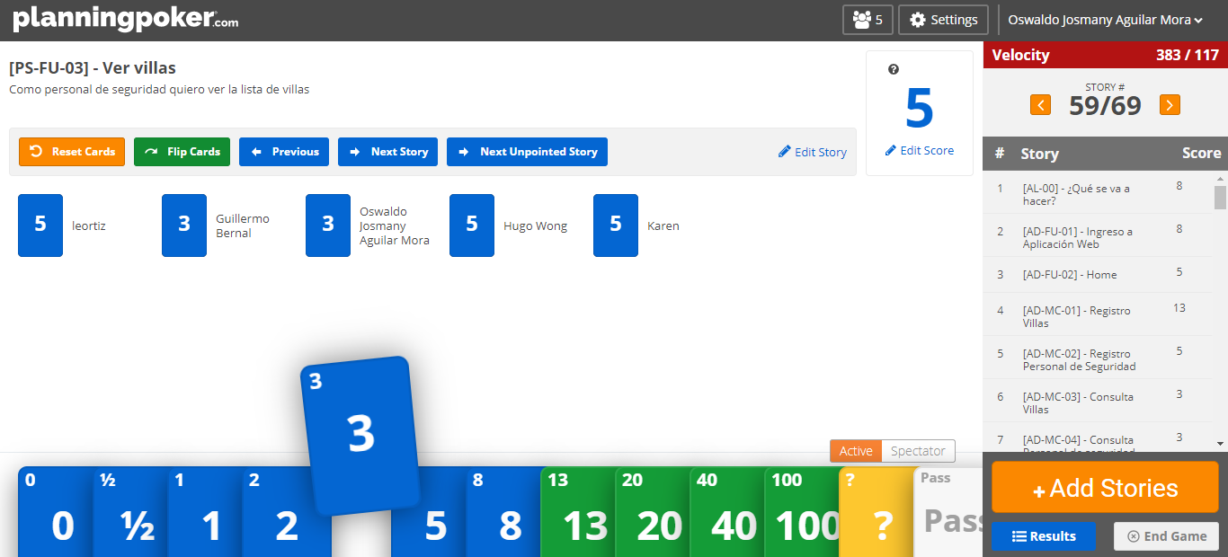

**Figure 4. Scrum Poker Platform - Story 59**

* 1. Backlog

|  |  |  |  |
| --- | --- | --- | --- |
| **CODE** | **DETAIL** | **PRIORITY** | **ESTIMATE** |
| **AL-00** | **As a** client (Alameda), **I want** residents and security staff to have mobile applications controlled by a web application for the administrator with the persistence of data in a BD. | **Urgent** | 8 |
| **AD-FU-01** | **As an** administrator, **I want** to be able to enter the web control module with my username and password. | **High** | 8 |
| **AD-FU-02** | **As an** administrator, **I want** to be able to see all the options offered by the application and the main page. | **Normal** | 5 |
| **AD-FU-03** | **As an** administrator, **I want** to be able to consult my registered information. | **Low** | 2 |
| **AD-FU-04** | **As an** administrator, **I want** to be able to edit my registered information. | **Low** | 3 |
| **AD-FU-05** | **As** **an** administrator, **I want** to be able to generate a new item to be collected for all residences. | **High** | 3 |
| **AD-FU-06** | **As an** administrator, **I want** to be able to generate a new item to be charged per villa, | **Low** | 3 |
| **AD-FU-07** | **As an** administrator, **I want** to be able to change the status of an item of a villa to "PAID / CANCELED" or "DEBT" with its respective value. | **High** | 2 |
| **AD-FU-08** | **As an** administrator, **I want** to be able to see the general balance of debts of each residence. | **Normal** | 5 |
| **AD-FU-09** | **As an** administrator, **I want** to see the current debts of the resident. | **High** | 2 |
| **AD-FU-10** | **As an** administrator, **I want** to see the payment history of a residence. | **Normal** | 3 |
| **AD-FU-11** | **As an** administrator, **I want** to see all the payment items created. | **High** | 2 |
| **AD-FU-12** | **As an** administrator, **I want** to see the information on a specific payment item. | **Low** | 2 |
| **AD-FU-13** | **As an** administrator, **I want** to see the general balance of the payment status of the payment item. | **Normal** | 5 |
| **AD-FU-14** | **As an** administrator, **I want** to see a list of the villas missing to cancel the payment item. | **Normal** | 2 |
| **AD-FU-15** | **As an** administrator, **I want** to edit the information of an existing payment item. | **Low** | 2 |
| **AD-FU-16** | **As an** administrator, **I want** to delete a created payment item. | **Normal** | 3 |
| **AD-FU-17** | **As an** administrator, **I want** to see the history of visits by the villa. | **Normal** | 3 |
| **AD-FU-18** | **As an** administrator, **I want** to see the visit history of Alameda. | **High** | 3 |
| **AD-FU-19** | **As an** administrator, **I want** to receive daily reports of visits to the urbanization. | **High** | 13 |
| **AD-FU-20** | **As an** administrator, **I want** to receive daily reports on the status of the items and debts in the urbanization. | **High** | 13 |
| **AD-FU-21** | **As an** administrator, **I want** to see comments and suggestions from residents. | **Low** | 3 |
| **AD-FU-22** | **As** an administrator, **I want** to respond to these comments and suggestions. | **Low** | 2 |
| **AD-FU-23** | **As an** administrator, **I want** to receive daily reports of comments and suggestions. | **Low** | 5 |
| **AD-FU-24** | **As an** administrator, **I want** to be able to mark or categorize the comments and suggestions that I receive. | **Low** | 3 |
| **AD-FU-25** | **As an** administrator, **I want** to be able to log out of the web system. | **High** | 1 |
| **AD-MC-01** | **As an** administrator, **I want** to be able to register residents in the app. | **High** | 13 |
| **AD-MC-02** | **As an** administrator, **I want** to be able to register the security staff in the application. | **High** | 5 |
| **AD-MC-03** | **As an** administrator, **I want** to be able to consult the accounts of the residents. | **Normal** | 3 |
| **AD-MC-04** | **As an** administrator, **I want** to be able to consult the accounts of the security staff. | **Normal** | 3 |
| **AD-MC-05** | **As an** administrator, **I want** to be able to edit the profile fields of the residents' accounts. | **Low** | 4 |
| **AD-MC-06** | **As an** administrator, **I want** to be able to edit the profile fields of the security person's accounts. | **Low** | 2 |
| **AD-MC-07** | **As an** administrator, **I want** to be able to cancel the account associated with a resident. | **Low** | 2 |
| **AD-MC-08** | **As an** administrator, **I want** to be able to cancel the account associated with a member of the security staff. | **Low** | 2 |
| **RE-FU-01** | **As a** resident, **I want** to be able to enter the mobile application with my username and password. | **High** | 13 |
| **RE-FU-02** | **As a** resident, **I want** to be able to see all the options offered by the application and the main page. | **Normal** | 8 |
| **RE-FU-03** | **As a** resident, **I want** to be able to consult my personal information. | **Low** | 5 |
| **RE-FU-04** | **As a** resident, **I want** to be able to edit my allowed information. | **Low** | 20 |
| **RE-FU-05** | **As a** resident, **I want** to see the current items pending payment. | **High** | 8 |
| **RE-FU-06** | **As a** resident, **I want** to see the history of my payment items. | **Low** | 13 |
| **RE-FU-07** | **As a** resident, **I want** to see my active visitor invitations. | **High** | 13 |
| **RE-FU-08** | **As a** resident, **I want** to generate new invitations | **High** | 8 |
| **RE-FU-09** | **As a** resident, **I want** to edit active invitations. | **Low** | 8 |
| **RE-FU-10** | **As a** resident, **I want** to cancel active invitations. | **Normal** | 13 |
| **RE-FU-11** | **As a** resident, **I want** to see my visitor list. | **Normal** | 8 |
| **RE-FU-12** | **As a** resident, **I want** to add a new visitor. | **Normal** | 5 |
| **RE-FU-13** | **As a** resident, **I want** to see the detail of the visitors. | **Low** | 3 |
| **RE-FU-14** | **As a** resident, **I want** to edit the detail of the visitors. | **Low** | 8 |
| **RE-FU-15** | **As a** resident, **I want** to remove a visitor from my list. | **Low** | 8 |
| **RE-FU-16** | **As a** resident, **I want** to be notified when the visitor shows up at the sentry box of the urbanization. | **High** | 5 |
| **RE-FU-17** | **As a** resident, **I want** to be able to accept the visitor's income once it arrives. | **High** | 8 |
| **RE-FU-18** | **As a** resident, **I want** to have a communication channel with a sentry box. | **Low** | 5 |
| **RE-FU-19** | **As a** resident, **I want** to see my comments and suggestions sent. | **Low** | 5 |
| **RE-FU-20** | **As a** resident, **I want** to be able to send new comments and suggestions. | **Low** | 3 |
| **RE-FU-21** | **As a** resident, **I want** to be able to see the administrator's response to my comments or suggestions. | **Low** | 3 |
| **RE-FU-22** | **As a** resident, **I want** to be able to log out. | **High** | 2 |
| **PS-FU-01** | **As a** Security Staff, **I want** to be able to enter the mobile application with my username and password. | **High** | 3 |
| **PS-FU-02** | **As a** security staff, **I want** to be able to see all the options offered by the application and the main page. | **Normal** | 3 |
| **PS-FU-03** | **As a** security staff, **I want** to see the list of villas. | **High** | 5 |
| **PS-FU-04** | **As a** security staff, **I want** to see the basic information about the villa. | **Normal** | 8 |
| **PS-FU-05** | **As a** security staff, **I want** to see the villas that are in “mora”. | **High** | 5 |
| **PS-FU-06** | **As a** security staff, **I want** to see the active visits of the day. | **High** | 5 |
| **PS-FU-07** | **As a** security staff, **I want** to be able to enter the invitation code and verify the data | **High** | 8 |
| **PS-FU-08** | **As a** security staff, **I want** to inform the resident of the arrival of the visit to the sentry box. | **High** | 5 |
| **PS-FU-09** | **As a** security staff, **I want** to mark the entrance of the visit. | **Normal** | 3 |
| **PS-FU-10** | **As a** security staff, **I want** to mark the departure of the visit. | **Low** | 3 |
| **PS-FU-11** | **As a** security staff, **I want** to have a communication channel with the villas/residents. | **Low** | 3 |
| **PS-FU-12** | **As a** security staff, **I want** to log out. | **High** | 1 |
| **PS-FU-13** | **As a** Security Staff, **I want** to be able to see the residents per villa on a map so I can give directions to visitors. | **Normal** | 20 |

**Table 4.- User Stories Backlog**

* 1. Dependencies

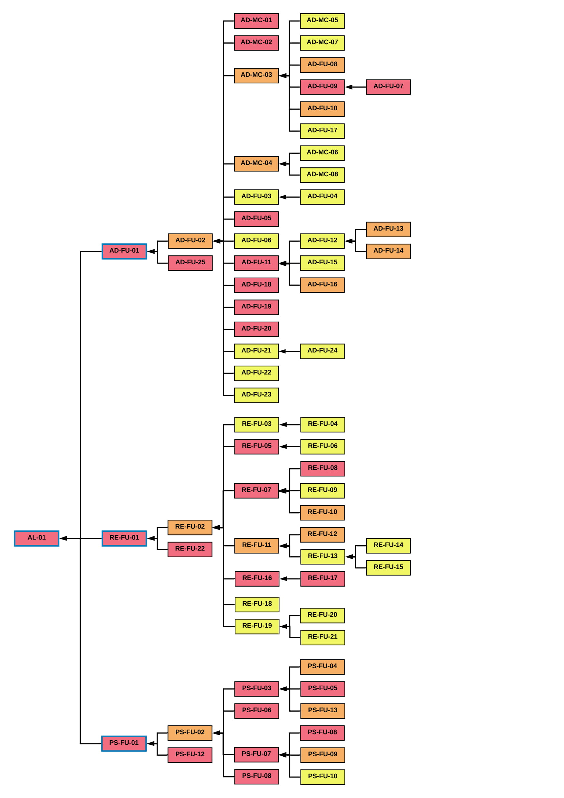

**Figure 5. User stories dependencies**

1. Project Control
   1. Click Up

The task management platform of this project is **“Click up”**, at the beginning of the project was **“Asana”** but in the free version of this isn’t the link of dependencies between stories, for this reason, the team decided to change the platform.

The link to the project “Click up” environment is <https://app.clickup.com/4208477/v/l/5-16514668-1?pr=10203943>.

Environment Structure:

* Backlog
* Sprint 1
* Sprint 2
* Sprint 3
* Bugs
* Meetings
* Other Tasks

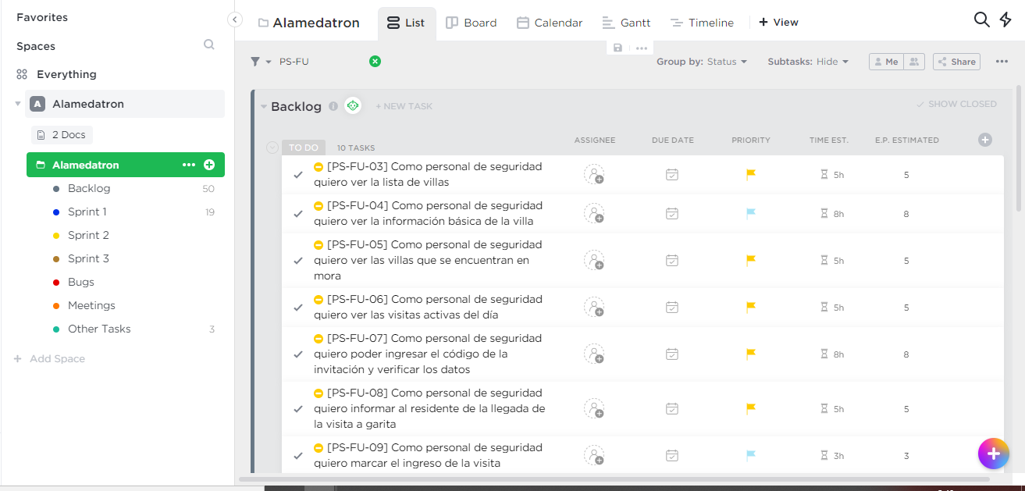

**Figure 6.- Principal page of Click Up project.**

Story Format:

* Code of Story
* Members Assigned
* Subtasks
* Dependencies
* GitHub Connection
* Time Estimated
* Comments

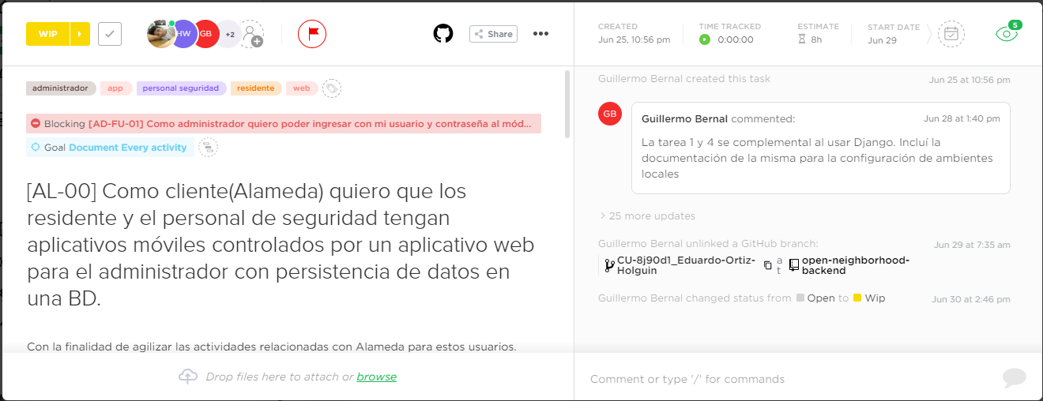

**Figure 7. User story task in Click Up**

An important characteristic of Click up is the Github connection, the members before start coding should link the repository and create the branch.

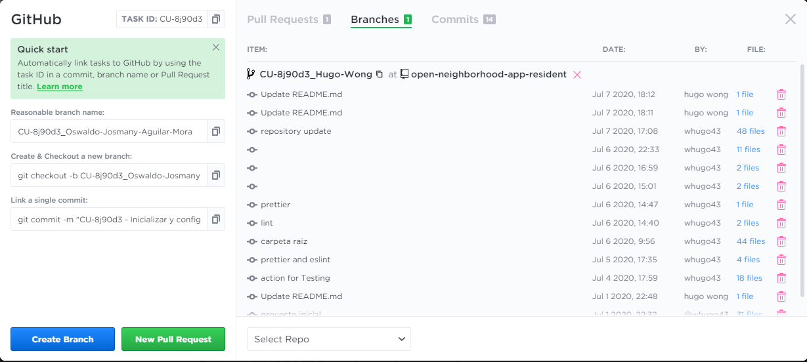

**Figure 8. Github Connection to a tasks or subtask**

Another important characteristic of Click Up is the time control of activities, with only a click a timer starts and helps report the developing time.

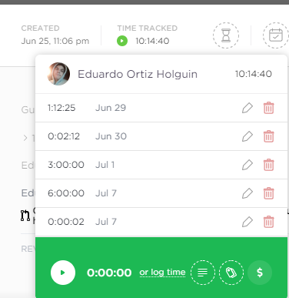

**Figure 9. Time tracker of a task in Click up**

Finally Click up have the option of document creation, which helps converge all information and also have a variety of views.

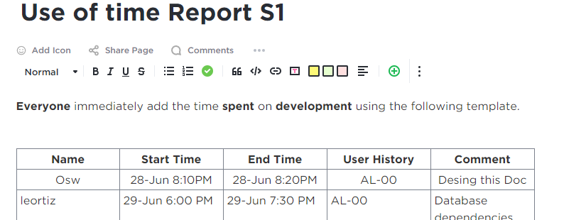

**Figure 10.- Use of Time S1 Document in Click Up**

* 1. GitHub

In this project in order to facilities the project control, the team created five repositories:

* Documentación: <https://github.com/Oswagui/-Documentation-open-neighborhood->
* Web – Frontend: <https://github.com/Bernix01/open-neighborhood>
* Web - Backend: <https://github.com/Bernix01/open-neighborhood-backend>
* Security Staff Mobile App: <https://github.com/Bernix01/open-neighborhood-app-security>
* Resident Mobile App: <https://github.com/Bernix01/open-neighborhood-app-security>

Additionally, the team follow a strict protocol of commits, branches, pull requests, and check:

* First, the member should be creating a branch of task with the link in Click up Platform.
* Code and Commits.
* Pull Request.
* Pass Tests and Code Stilling.
* Resolve Conflict.
* Assign a Reviewer.
* Check and comment.
* Accept the pull Request.

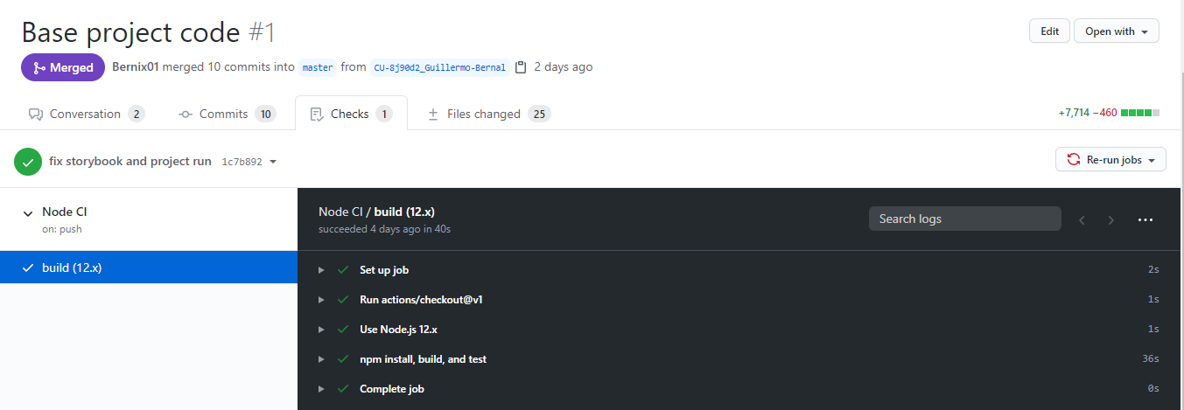

**Figure 11.- Github Test and Accept**

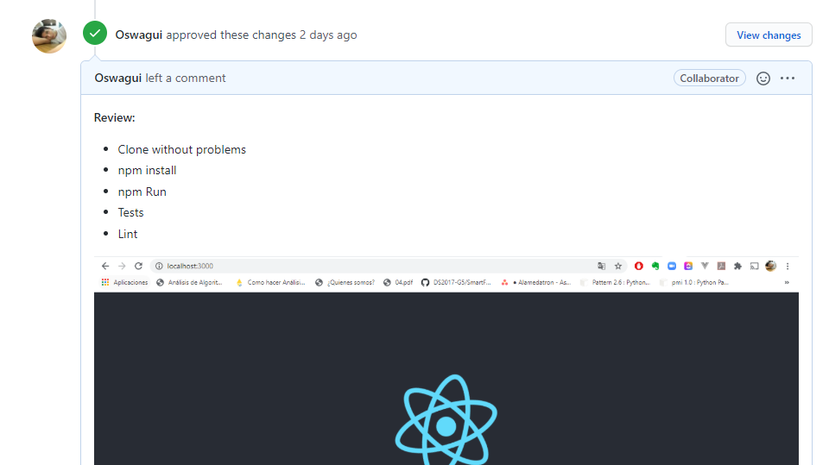

**Figure 12. Github pull reviewer**

* 1. Teams

The team has a private channel in course teams, in the files section, have a compilation of all documents of the project. Additionally, this platform is the meeting platform for the group.

* 1. Meetings Rules

The meetings are important in this project and are divided in the following types:

* Scrum Meetings.
* Teacher Guide Meetings.
* Bugs Resolution Meetings.
* Technology Explanation Meetings.
* Other Meetings.

The rules are:

* Daily Scrum Meeting will be from Monday to Saturday at 7:30 pm.
* Is obligatory assist to Sprint Planification Meeting.
* The assistance of Daily Scrum Meeting is important but in case of a problem or member’s inability to attend this, the member should advise Scrum master and send the answer to the Daily Scrum questions.
* The Bugs Resolution, Technology Explanation is optional but is obligatory to check the records of the meeting.
* In case the Scrum Master can’t assist to a Meeting should assign a represent and host of the meeting.
* The meeting minutes will be in teams and “click up” platform, but the sign of these will be postponed to a future date.
* The tutor guide meetings will be in the subject class hour.
* The Scrum Master can schedule an Urgent Meeting with obligatory attendance of members-only in the case that the members will be notified with a day of anticipation.

1. Technology, Tools and implementation decisions
   1. Overview

|  |  |
| --- | --- |
| **TECHNOLOGY/TOOL** | **USE** |
| React Native and React.js | Mobile App Framework and JavaScript library. |
| React Hook | React API, Hooking techniques. |
| Graphql | Query Language in Client-Side |
| Graphql Hooks | Alternative API to Apollo Hooks in Client-Side |
| Django | Web framework in server-side |
| Django Graphene | Add Graphql functionality in Django Project |
| Grommet | Uikit, React-based framework that provides accessibility, modularity, responsiveness, and themes in a tidy package. |
| GitHub Actions | Build Automation |
| Airbnb | Coding Standard |
| EsLint | Enforcing coding standards |
| EsLint | Preemptive Error Detection |
| Jest | Test Cases frontend |
| Django Test Cases Graphene Test Case | Test Cases backend |
| Chrome DevTools | Profiling web |
| Android Studio profiling tool | Profiling apps |
| Django Roles | Roles Control Tool |
| graphql-jwt | Authentication Tool |
| Windows Server 2013 | Server Operating System |
| PostgreSQL | Server DataBase |

**Table 5.- Overview of tools and technology in the project**

* 1. React Native and React.js

The Scrum team decided to have **React Native** as the mobile application framework of the project and **React.js** was chosen as the **JavaScript** library to build the user interfaces for Alameda’s Administrator.

The main reason for the decision to choose React Native and ReactJS is to reduce the learning load of development members and to facilitate collaborative work both on the web app and mobile app.

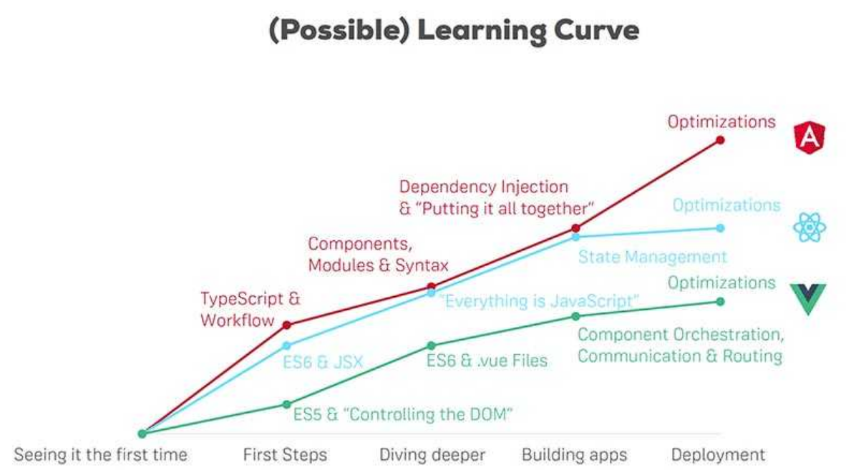

**Figure 13.- Learning Curve - React, Angular and Vue**

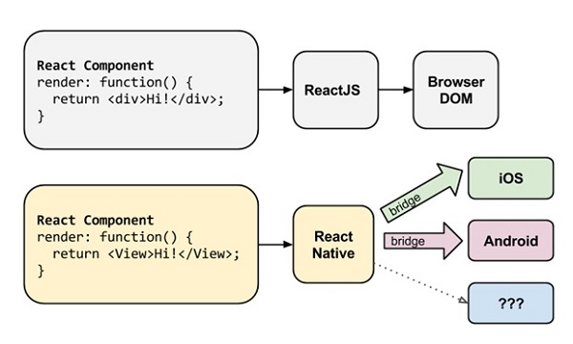

**Figure 14.- Code Sharing between ReactJS and React Native**

* 1. React Hook

The Scrum team decided to use the React API to implement the Hooking technique in the project.

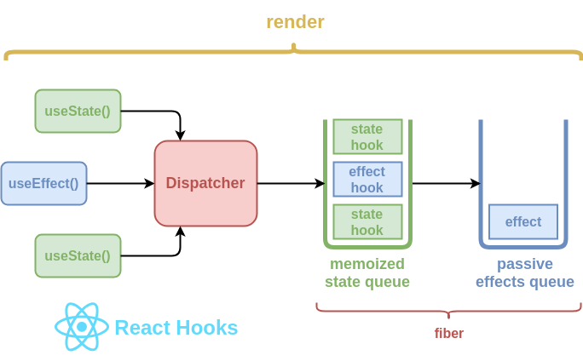

**Figure 15. React Hooks**

* 1. GraphQL

The Scrum team decided to have **GraphQL** as the query language in the Client Side. GraphQL provides a complete and understandable description of the data.

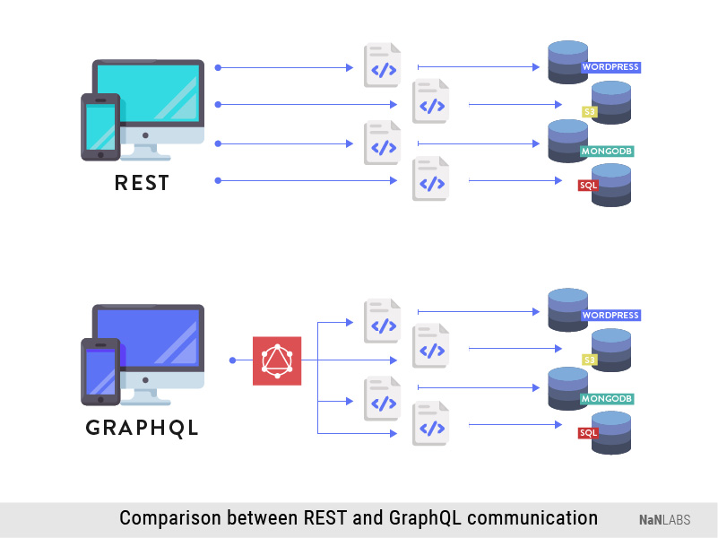

**Figure 16. Comparison of Rest and GraphQL communication.**

* 1. Django

The Scrum team decided to have **Django** as the web framework on the server-side. The main reason for the decision to choose Django and ReactJS is to reduce the learning time and facilitate the development thanks to the team's previous experience using Python and Django. Django follows the model-template-view (MVC) architectural pattern.

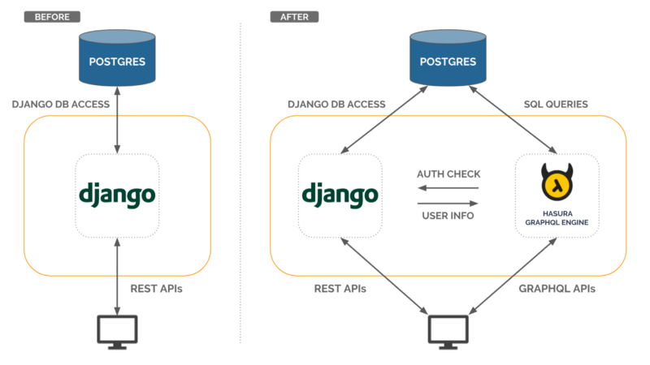

**Figure 17. GraphQl and Django communication**

* 1. Django Graphene

The Scrum team decided to have **Django Graphene** as GraphQL functionality in the Django Project.

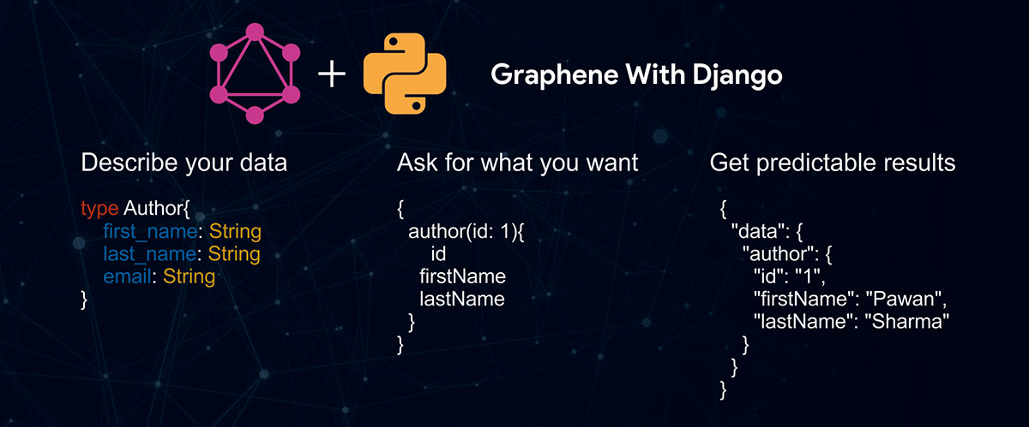

**Figure 18. Django and Graphene**

* 1. Grommet

The Scrum team decided to have **Grommet** as the React-based framework that provides accessibility, modularity, responsiveness, and theming in a tidy package. And the grommet designer to make the views.

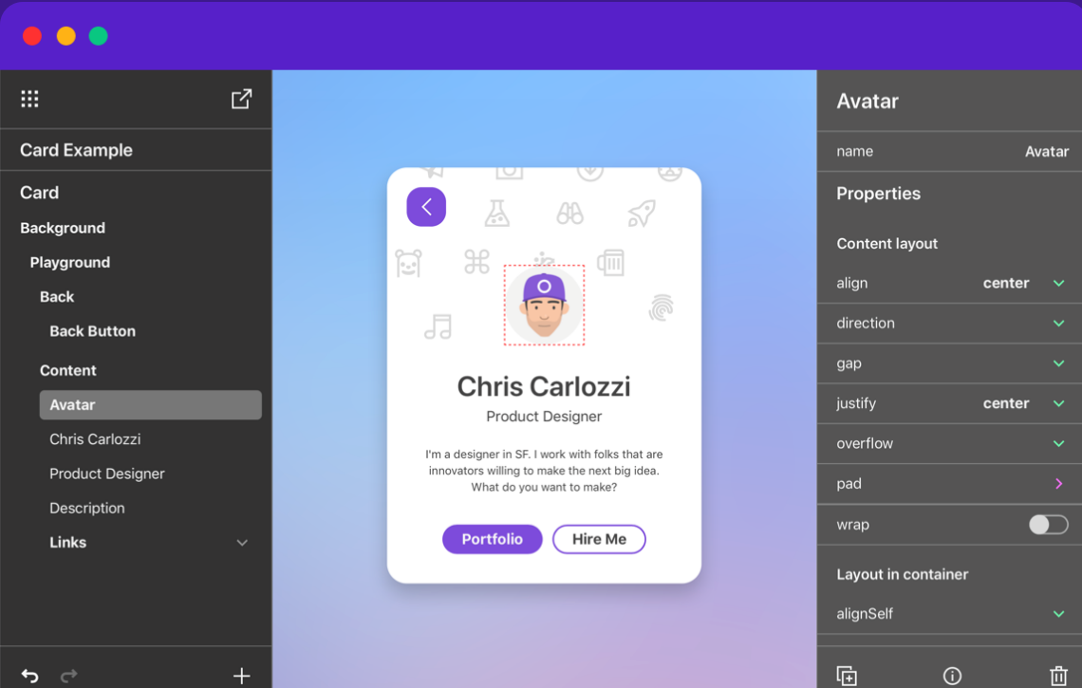

**Figure 19. Grommet Designer**

* 1. EsLint

The Scrum team decided to have **EsLint** as the tools for Enforcing coding standards

and Preemptive Error Detection. The main reason to choose this tool is the facility of use.



**Figure 20. EsLint, React and Airbnb**

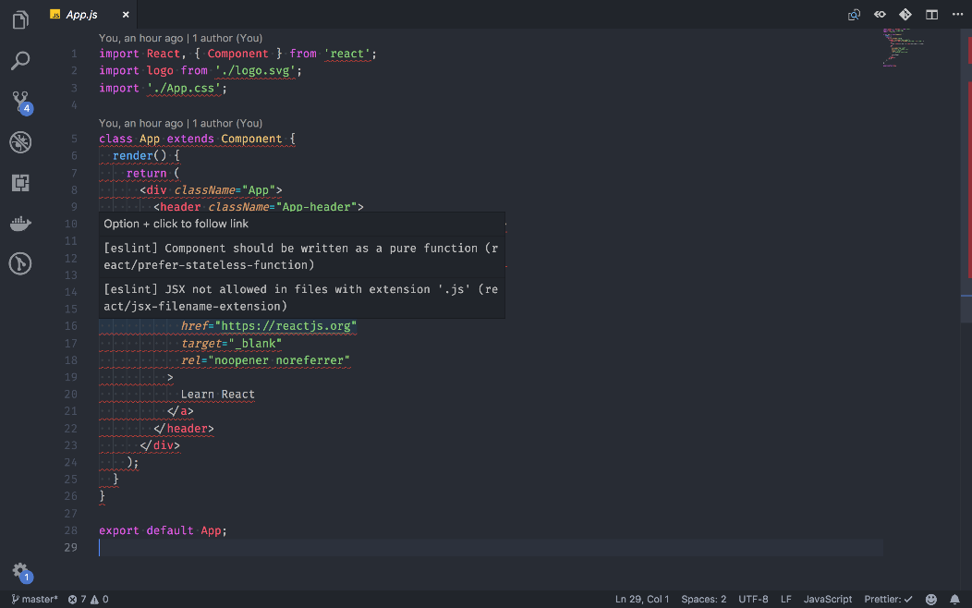

**Figure 21. EsLint example**

* 1. Airbnb Style Guide

The Scrum team decided to have **Airbnb Style Guide** as the React style guide in the project. This style guide is mostly based on the standards that are currently prevalent in JavaScript, although some conventions (i.e async/await or static class fields) may still be included or prohibited on a case-by-case basis. Currently, anything prior to stage 3 is not included nor recommended in this guide.

Read the full guide in: <https://github.com/airbnb/javascript/tree/master/react>

Style Guide points:

* Basic Rules
* Class vs React.createClass vs stateless
* Mixins
* Naming
* Declaration
* Alignment
* Quotes
* Spacing
* Props
* Refs
* Parentheses
* Tags
* Methods
* Ordering
* isMounted
  1. Jest

The Scrum team decided to have **Jest** as JavaScript testing framework It works with projects using: Babel, TypeScript, Node.js, React, Angular and Vue.js. It aims to work out of the box and config free.

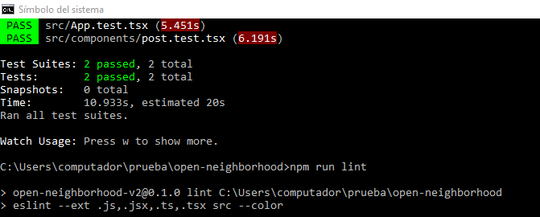

**Figure 22. EsLint test**

* 1. Chrome DevTools

The Scrum team decided to have **Chrome DevTools** as a Web app profiler. Is the easiest and the documentation is extensive.

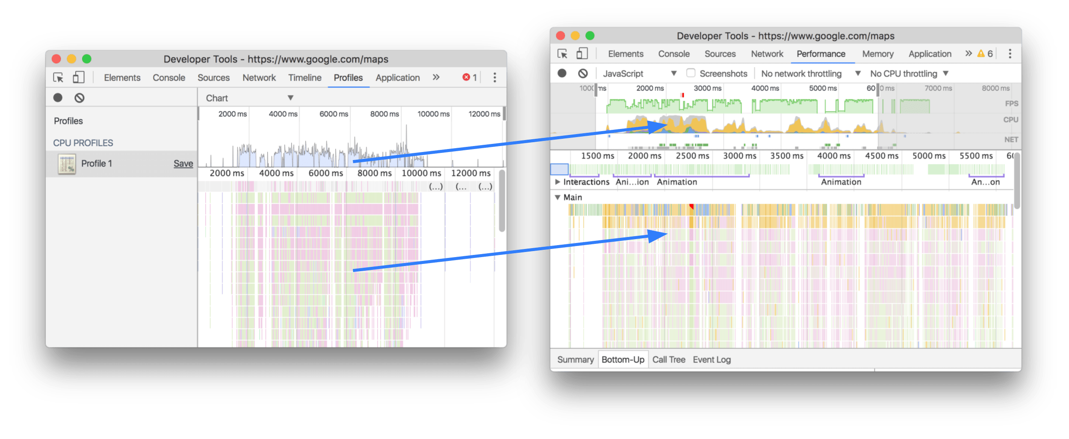

**Figure 23. Chrome WebTools profiler**

* 1. Android Profiler

The Scrum team decided to have **Android Profiler** as a Mobile app profiler. Is the easiest and the documentation is extensive.

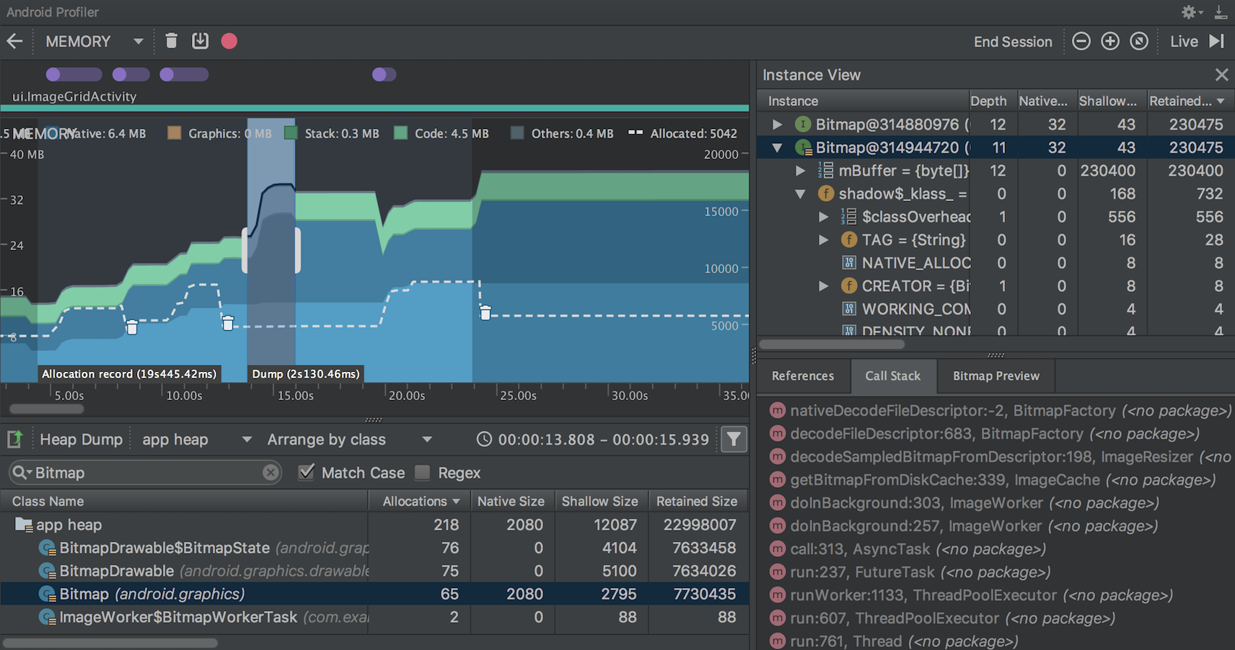

**Figure 24. Android Profiler**

* 1. Django Roles and GraphQL-JWT

The Scrum team decided to have **Django Roles** as the Roles Control tool and **GraphQL-JWT** as the Authentication tool.

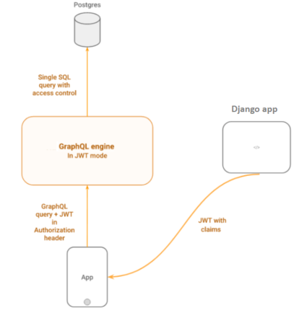

**Figure 25. GraphQL JWT and Django**

* 1. Windows Server 2003

The Client has **Windows Server 2003** as the operating system in the server.

* 1. PostgreSQL

The Client indicated the change of the database engine from SQL Server to **PostgreSQL**.

1. Pre-Sprint
   1. Meetings

|  |  |  |
| --- | --- | --- |
| **MEETING** | **DATE-TIME** | **TYPE** |
| Asana migration | 23/06/2020 09:33 PM | Optional |
| Teacher Guide 1 | 24/06/2020 02:45 PM | Feedback |
| Scrum Poker | 26/06/2020 11:00 AM | Obligatory |

**Table 6.- Pre Sprint-Meetings**

* 1. Considerations
* The meeting minutes are in Teams and Click-up.
* The first evidence of these meetings was in Asana but a time later the team migrate to Click-up.
* Redefinition, creation, and estimations of stories were in this period.

1. Sprint 1
   1. Week 1

* Start of AL-00 story.
* Hard week, the team presents a lot of problems with the platforms and languages.
* Bad estimation of AL-00 story, the configuration, and the familiarization with the languages, frameworks, and tools require more time.
* Click up Migration.
* Define tools, frameworks and technology.
* Define Coding Standards.
* Start report of first partial.
  1. Week 2
* End of AL-00 story.
* Check pull request of Web environment.
* Check pull request of Resident Mobile App environment.
* Check pull request of the Security Staff App environment.
* Definition of Profiling Tool.
* Continues report of first partial.
  1. Week 3
* Continues report of first partial.
* Configuration of the user in the web server. (14/07/2020)
* Configuration of the web server.
* Learn Grommet.
* Start AD-FU-01, AD-FU-02.
* Add PostgreSQL to the project.
* First Partial Report.
* Github Documentation Repo.
* Early Sprint 1 Acceptance Act.
  1. Meetings

|  |  |  |
| --- | --- | --- |
| **MEETING** | **DATE-TIME** | **TYPE** |
| Daily Scrum 1 | 29/06/2020 07:30 PM | Scrum |
| Daily Scrum 2 | 30/06/2020 07:30 PM | Scrum |
| Teacher Guide 2 | 01/07/2020 03:42 PM | Feedback |
| Daily Scrum 3 | 01/07/2020 07:30 PM | Scrum |
| Daily Scrum 4 | 02/07/2020 07:30 PM | Scrum |
| Daily Scrum 5 | 03/07/2020 07:30 PM | Scrum |
| Technology Meeting 1 | 04/07/2020 12:30 PM | Optional |
| Daily Scrum 6 | 04/07/2020 07:30 PM | Scrum |
| Daily Scrum 7 | 06/07/2020 07:30 PM | Scrum |
| Daily Scrum 9 | 08/07/2020 07:30 PM | Scrum |
| Daily Scrum 10 | - | Scrum |
| Daily Scrum 11 | - | Scrum |
| Daily Scrum 12 | 08/07/2020 07:30 PM | Scrum |
| Daily Scrum 13 | 13/07/2020 07:30 PM | Scrum |
| Daily Scrum 14 | 14/07/2020 07:30 PM | Scrum |
| Daily Scrum 15 | 15/07/2020 08:30 PM | Scrum |

**Table 7.- Sprint 1 Meetings**

* 1. Client Acceptance
* See the full document in the Repository.

1. ESPOL have a Software Engineering program that consists in two courses in two semesters, the project in the second course is a continuation of the project in the first semester.
2. PhD. Carlos Mera in the course of Software Engineering II increase teams’ size to 5 members.
3. In the final of first semester of the year Ecuador was affect with a global pandemic, this pandemic was occasioned for the COVID-19 virus, mobility restrictions were decreed in order mitigate the pandemic. This restriction affects the scope of the project.
4. The project partial report is scheduled for July 15 of 2020, this correspond to the middle of third week of the first sprint.